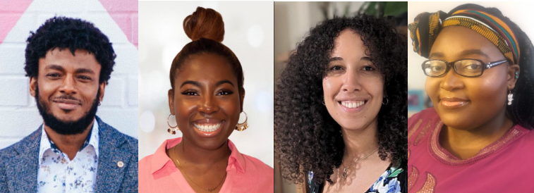

SPEAKERS (from left)
Corey Brotherson is an award-winning Birmingham-based freelance writer, editor and creative consultant who has built a 22-year career in the videogames industry writing for over a dozen companies, including PlayStation, King and Apple. He is the narrative designer/writer for the in-development adventure game Windrush Tales, worked as lead narrative designer for Surgent Studios, and became a full member of BAFTA in 2022 after two consecutive years as a BAFTA Game Awards judge.
Thara Popoola is a comedy and drama writer based in London and Milton Keynes. She has a legal background but ventured into screenwriting around five years ago. Since then, Thara has completed the Channel 4screenwriting course (2021), written episodes on Sex Education (Netflix) and Queenie (Channel 4), and has numerous original projects in development. Thara was featured on the Forbes 30 under 30 2023 Entertainment list and has co-founded Black Women in Scripted, a network for black women and non-binary people in the Film and TV industry to connect, share opportunities and celebrate one another.
Mariama Ives-Moiba is a writer for Children’s and Adult’s TV, who is passionate about putting black women at the forefront of her work. She is a winner of the BAFTA Rofcliffe New Writing Competition, and was part of the BBC New Voices programme, 2021. Mariama draws heavily on her mixed Sierra Leonean and English heritage, to broaden the perspective of her characters and her audience. She has written on a variety of live action and animated shows such as Doctors, Nova Jones, The Rubbish World of Dave Spud and JoJo and Gran Gran. As a former competitive swimmer and teacher, she looks forward to one day seeing a former pupil at the Olympics.
Matilda Feyiṣayọ Ibini is an award-winning bionic playwright and screenwriter of Nigerian heritage from London. Theatre credits include: Little Miss Burden and Sleepova. Screen credits include: BAFTA TV-Nominated CripTales MO <3 KYRA, a short film produced by Film4 and 104 Films which debuted at this year’s BFI London Film Festival. They co-wrote an episode on Amazon Prime’s series Wilderness (2023) produced by Firebird Pictures. Matilda has screen projects in development.

